How to access Khan Academy, if your teacher has not already shown you how

- Log into MyPortal (https://acps.gg4l.com/#/authPage)

- Choose box 4. Supplemental
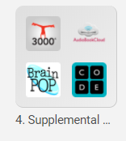

- Select Khan Academy button
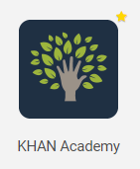

- Choose “Continue with Google” to log in

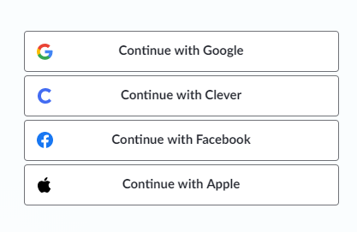

- Select “Let’s get started”
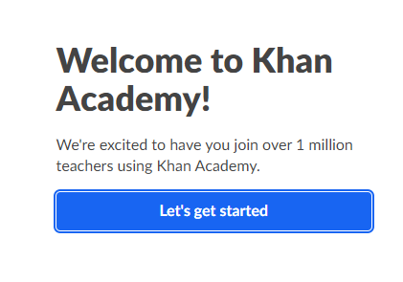
- Click on your username in the top right corner and change to “Learner home”
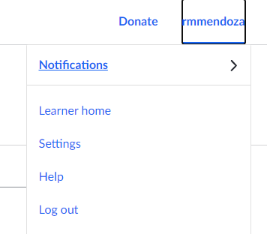

- Select the grade level(s) and courses you want to learn about
